Depth

Definition
# Source: AI Source: Provided by: [Data Path: Persons Table -> ID Column: 1, Name_En Column: Motasem Essam] -> From: [ChatGPT] on [7/17/2026]
Depth is the measurement of an object's extent from the front to the back. It represents the third principal dimension of a three-dimensional object, perpendicular to both its length and width.
Depth describes how far an object extends inward or backward from its front surface.

Characteristics
# Source: AI Source: Provided by: [Data Path: Persons Table -> ID Column: 1, Name_En Column: Motasem Essam] -> From: [ChatGPT] on [7/17/2026]
Depth:
- Measures the distance from the front of an object to its back.
- Is perpendicular to both the length and width.
- Is expressed as a linear measurement.
- Can be measured using metric or imperial units.
- Is one of the three principal dimensions of three-dimensional objects.

Illustration
# Source: AI Source: Provided by: [Data Path: Persons Table -> ID Column: 1, Name_En Column: Motasem Essam] -> From: [ChatGPT] on [7/17/2026]
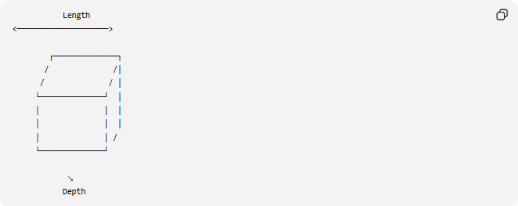
Length
<────────────────────>

┌──────────────┐
/ /│
/ / │
└──────────────┘ │
│ │ │
│ │ │
│ │ /
└──────────────┘

↘
Depth

Measurement Units
# Source: AI Source: Provided by: [Data Path: Persons Table -> ID Column: 1, Name_En Column: Motasem Essam] -> From: [ChatGPT] on [7/17/2026]
Depth may be measured using:
Metric Units
- Millimeter (mm)
- Centimeter (cm)
- Meter (m)
- Kilometer (km)
Imperial Units
- Inch (in)
- Foot (ft)
- Yard (yd)
- Mile (mi)

Measuring Instruments
# Source: AI Source: Provided by: [Data Path: Persons Table -> ID Column: 1, Name_En Column: Motasem Essam] -> From: [ChatGPT] on [7/17/2026]
Common instruments used to measure depth include:
- Ruler
- Measuring Tape
- Vernier Caliper (Depth Rod)
- Depth Gauge
- Depth Micrometer
- Laser Distance Meter
- Coordinate Measuring Machine (CMM)

Examples
# Source: AI Source: Provided by: [Data Path: Persons Table -> ID Column: 1, Name_En Column: Motasem Essam] -> From: [ChatGPT] on [7/17/2026]
Depth can describe the measurement of:
- A drawer
- A cabinet
- A bookshelf
- A desk
- A storage box
- A swimming pool
- A room

Mathematical Representation
# Source: AI Source: Provided by: [Data Path: Persons Table -> ID Column: 1, Name_En Column: Motasem Essam] -> From: [ChatGPT] on [7/17/2026]
Depth is commonly represented by:
$$d$$
Example:
A box has:
- Length = 40 cm
- Width = 25 cm
- Depth = 18 cm

Relationship to Other Dimensions
# Source: AI Source: Provided by: [Data Path: Persons Table -> ID Column: 1, Name_En Column: Motasem Essam] -> From: [ChatGPT] on [7/17/2026]
For a rectangular prism:
$$V=l×w×d$$
where:
- $V$= Volume
- $l$= Length
- $w$= Width
- $d$= Depth

Applications
# Source: AI Source: Provided by: [Data Path: Persons Table -> ID Column: 1, Name_En Column: Motasem Essam] -> From: [ChatGPT] on [7/17/2026]
Depth measurement is used in:
- Geometry
- Engineering
- Architecture
- Construction
- Manufacturing
- Furniture Design
- Interior Design
- CAD (Computer-Aided Design)
- Packaging
- Quality Control

Advantages
# Source: AI Source: Provided by: [Data Path: Persons Table -> ID Column: 1, Name_En Column: Motasem Essam] -> From: [ChatGPT] on [7/17/2026]
Measuring depth helps to:
- Describe three-dimensional object size.
- Calculate volume.
- Verify design specifications.
- Ensure proper fit of components.
- Support engineering and manufacturing processes.

Limitations
# Source: AI Source: Provided by: [Data Path: Persons Table -> ID Column: 1, Name_En Column: Motasem Essam] -> From: [ChatGPT] on [7/17/2026]
Depth:
- Depends on the selected front reference surface.
- May vary for irregularly shaped objects.
- Requires appropriate measuring instruments for precise measurements.

Comparison with Other Dimensions
# Source: AI Source: Provided by: [Data Path: Persons Table -> ID Column: 1, Name_En Column: Motasem Essam] -> From: [ChatGPT] on [7/17/2026]
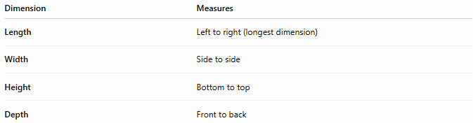
Dimension | Measures
Length | Left to right (longest dimension)
Width | Side to side
Height | Bottom to top
Depth | Front to back

Key Points
# Source: AI Source: Provided by: [Data Path: Persons Table -> ID Column: 1, Name_En Column: Motasem Essam] -> From: [ChatGPT] on [7/17/2026]
- Depth measures the distance from the front of an object to its back.
- It is commonly represented by:
$$d$$
- Depth is one of the three principal dimensions used to describe three-dimensional objects.
- It is widely used in geometry, engineering, architecture, manufacturing, CAD, and product design.

Conclusion
# Source: AI Source: Provided by: [Data Path: Persons Table -> ID Column: 1, Name_En Column: Motasem Essam] -> From: [ChatGPT] on [7/17/2026]
Depth is the measurement of an object's front-to-back extent and is one of the fundamental dimensions used to describe three-dimensional objects. Together with length and width, it defines the overall size and contributes directly to volume calculations. Accurate depth measurement is essential in geometry, engineering, architecture, construction, manufacturing, furniture design, CAD, packaging, and quality control, where precise three-dimensional dimensions are required for design, analysis, and production.

